WC CAT Job for Terrorism Accumulation Run
(Feb Release 2017)
Details:
This WC CAT job is dependent on the below RMS job.
RMS Job Name: RMS -Weekly Run without RMS_EDM_ZNATR
Schedule:
QA: Every Monday at 8:30 AM CST.
Production: Every Monday at 8:30 PM CST.
WC CAT Job Name: WC_CAT_Terrorism_Accumulation_Run_Test
Package: WC_CAT_Terrorism_Accumulation_Run_Test
Schedule
QA: Every Monday at 9:00 AM CST (30 min after the RMS job is run).
Production: Every Monday at 9:00 PM CST (30 min after the RMS job is run).
The email for success/failure should go to the following people:
Ramesh Gangavarapu <ramesh.gangavarapu@zurichna.com>; Karuna Srikar, Sudheer Babu <skarunasrika@csc.com>; Gangone, Sunil Kumar <sgangone@csc.com>; ZNA RSP zna_rsp@csc.com; Oscar Sachin Padithem (Contractor) <oscar.sachin.padithem-c@zurichna.com>; Angalagunta, Ramu <rangalagunta@csc.com>; Michalski, Karen (External - ZurichNA) <Karen.Michalski@zurichna.com>; Scott Moore (Contractor) <scott.x.moore@zurichna.com>; Chris Wallis <chris.wallis@zurichna.com>; Ufheil, Bill (External - ZurichNA) <Bill.Ufheil@zurichna.com>; Janice Arias <janice.arias@zurichna.com>; Tatyana Strongin <tatyana.strongin@zurichna.com>; Mohit Mehra <mohit.mehra@zurichna.com>; Shaveta Gupta shaveta.gupta@zurichna.com
An automatic Success/Failure mail will be sent when the Job runs in Production.
Mail Service is only available in Production and not available in QA, so an automatic mail will not be delivered when the job runs in QA. We will send an email manually when the job runs in QA.

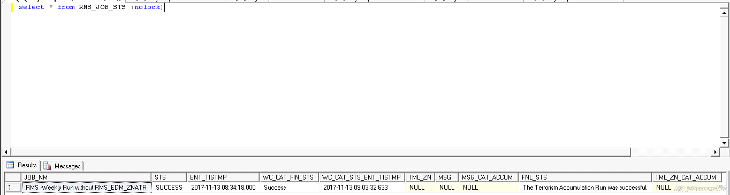
The status is updated in the above table whenever the job is excecuted. So this can be used to send the email when the job runs in QA.
QA
Server: DACLG1548
DB: CAS_WRKSTN
Table: RMS_JOB_STS
Columns:
JOB_NM – The RMS job name on which this WC CAT job is dependent
STS – Status of the RMS job
ENT_TISTMP – Timestamp when the RMS job was last run
WC_CAT_FIN_STS – Status of the WC CAT Job
WC_CAT_STS_ENT_TISTMP – Timestamp when the WC CAT job was last run
FIN_STS – The message that is delivered in the email. This message has the information regarding the missing TML zones in case of failure.
PRODUCTION
Server: PACLG1606
DB: CAS_WRKSTN
Table: RMS_JOB_STS
Columns:
JOB_NM – The RMS job name on which this WC CAT job is dependent
STS – Status of the RMS job
ENT_TISTMP – Timestamp when the RMS job was last run
WC_CAT_FIN_STS – Status of the WC CAT Job
WC_CAT_STS_ENT_TISTMP – Timestamp when the WC CAT job was last run
FIN_STS – The message that is delivered in the email. This message has the information regarding the missing TML zones in case of failure.
This WC Cat job will run on a specific submission provided by the WC CAT team. Every year when the submission expires and renewal submission is created, RAD team will update the database table with the renewed submission so that the Job runs on the updated submission.
Currently, the following submission is used for WC CAT job
QA: 1356179
Production: 16418934
This submission is available in the Appl_set table in cas_wrkstn
Appl_set_key: WCCatServiceSubmission
QA – daclg1548, Prod – paclg1606
Prerequisites for this job to run successfully:
- Submission should be available with a valid WC/WCX product.
- WC CAT Analysis should be created on the submission.
- Locations must be imported on the WC/WCX product for which WC CAT Analysis is created.
- RMS Job should run on time and it should be successful. If the RMS job doesn’t run or if it fails, WC CAT job also fails.
- WC CAT management team’s file must be available in the shared path. The file should not be in Edit mode by anyone. (WC CAT management team: 'Shaveta Gupta' <shaveta.gupta@zurichna.com>; 'Mohit Mehra' <mohit.mehra@zurichna.com>; 'Tatyana Strongin' <tatyana.strongin@zurichna.com>)
- Any modifications to the file name, file format, sheet name, column names, and the position of the rows and columns in the sheet will result in the (job) failure or incorrect final result. If any mandatory change is needed in the file, it should be done only after discussing with the WC CAT development team. (zna_rsp@csc.com, skarunasrika@csc.com, snalam@csc.com)

What this job does:
The first step of this job to check if the RMS Job is successful. If the RMS Job did not run or if it fails, the WC CAT job will not proceed to further steps and it will be failed. The RMS job successful run date should be the same day this job is running (otherwise the WC CAT job fails).
The job will also fail without checking for further steps, if

- Submission is expired
- WC/WCX product is not available
- Locations are not imported
- WC CAT analysis is not created

If all the above perquisites are met, the following steps will be performed on a specific submission (provided by WC CAT team) through the “WC_CAT_Terrorism_Accumulation_Run_Test” job. The details of the QA and Prod submission are mentioned earlier in this document.
1. WC CAT Run analysis is performed on the submission.
2. The data from Analysis Summary tab is dumped into one database table. WC_CAT_RUN_ANAL_DATA – DB: CAS_WRKSTN (Table is truncated before Dumping)
3. The data from WC CAT Management Team’s file (in shared path) is dumped into another database table. RMS_FL_DATA – DB: CAS_WRKSTN (Table is truncated before Dumping)
Shared path where the file will be placed. This same file is used for QA and Prod.
\\Uszzaschnas01\shared\ITDept\Workstation\WC CAT\WC CAT Accumulations

From this file, the following 4 highlighted columns are used from the TML_Area_Summary tab.
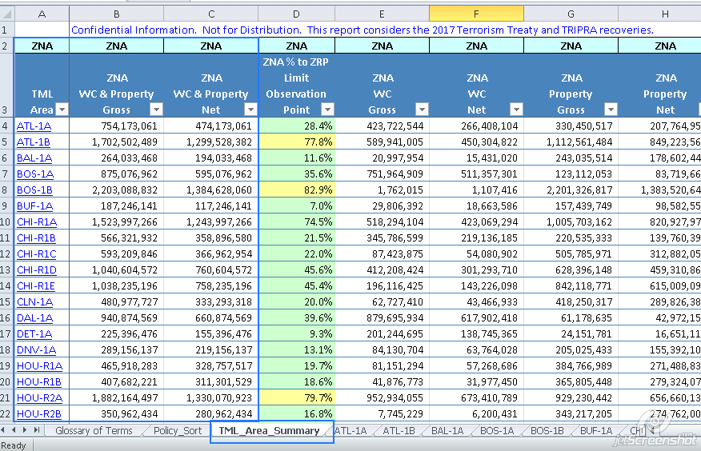

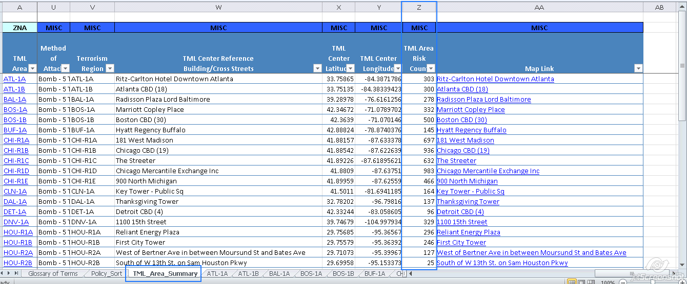
4. The data from these two database tables is taken and Delta is calculated for each row similar to the validation sheet (that Adam used to calculate manually). If Delta for each row (TML area) is between -1 and 1 (including -1 and 1), the job will return a success email. Otherwise, the job will return a failure email. This calculation is done using a Stored Procedure. Get_WCCat_Anal_Fin_Sts – DB: CAS_WRKSTN

Data Validation:

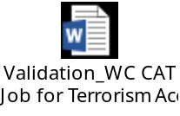
The steps 1 and 2 are done through one of the RAD Webservice methods. This web service method is invoked using a script component of the job.
The RAD Webservice details:
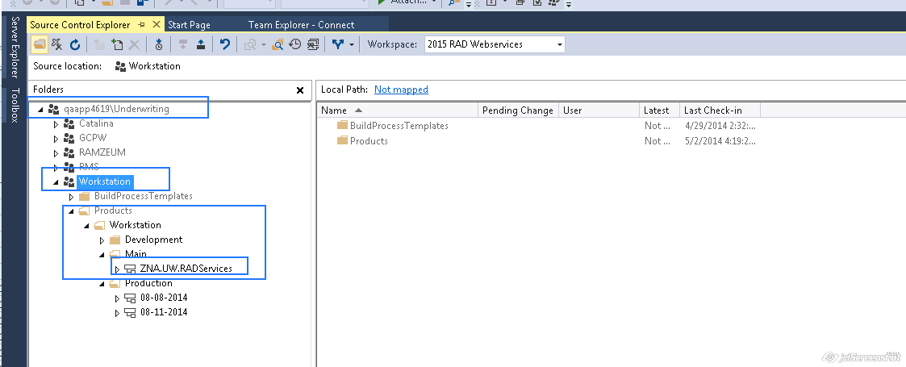

Method:
WCCATRunAnalysis

{Reference for calculations: (This is not used anywhere, but Adam used to use this file for the calculations before it was automated into job).
\\uszzaschnas01.sch.zus.us.zurich.com\shared\ITDept\Workstation\WC CAT\Validation Sheet for WC CAT Accumulations}

What needs to be done if the job fails:
- If the RMS job fails, the RMS team needs to be contacted
(Oscar Sachin Padithem<oscar.sachin.padithem-c@zurichna.com>; Angalagunta, Ramu <rangalagunta@csc.com>).
We need to rerun the WC CAT job after the RMS team successfully runs their job.
- If the WC CAT analysis is not created, locations are not imported or submission is expired, we need to correct the same in the application.
- If the job fails the calculation (of the Delta value) itself for any TML zone, same needs to be informed to the clients. The terrorism accumulation run will be unsuccessful, and the WC CAT management team will take appropriate actions.
- (The most common case in the recent days) If the job fails due to the TML zones missing in WC CAT analysis, we need to follow a few steps to successfully rerun the job again.
If the job fails due to this reason, the following message will be sent to clients in Production, and the database table column will be updated in QA.
The TML Zone(s) (e.g: ATL 1A, ATL 1B etc) are missing in WC CAT Analysis
The TML zones mentioned in the above message will be the TML zones that are missing. This happens if the locations imported on the submission in Workstation couldn’t generate those TML Zones in WC CAT Analysis Summary screen after Run Analysis. This happens if there is a location dropout—meaning the locations that fall in that TML zone are not imported on the submission, and the TML zone doesn’t show up after Run Analysis.
How to fix this:
To fix this we need to add locations for the missing TML zones and complete Run Analysis. If the Run Analysis produces the missing TML zones, then the issue is fixed. At this point we can rerun the WC CAT job, and it will be successful.

How do we get the locations:
The excel file provided by the WC CAT management team has all the details.
The locations related to the particular TML zone will be in the sheet named with that TML Zone. For example, if ATL – 1A TML zone is missing, the go to the tab named with ATL-1A, and add a few locations from that tab, and complete Run Analysis to see if the TML zone is populated. We need to keep adding locations until the TML zone populates in WC CAT analysis summary screen after Run Analysis.
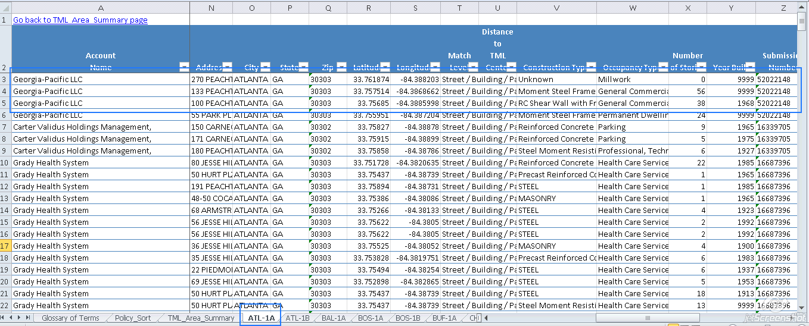

If the TML zone cannot be populated after adding all the locations, then same needs to be communicated to the clients.

